# R Module 1 Rubric

This R module is pretty simple; there aren’t that many difficult questions. Students should mostly just be able to load and run R Studio.

# Load data  
library(MASS)  
  
head(painters)

## Composition Drawing Colour Expression School  
## Da Udine 10 8 16 3 A  
## Da Vinci 15 16 4 14 A  
## Del Piombo 8 13 16 7 A  
## Del Sarto 12 16 9 8 A  
## Fr. Penni 0 15 8 0 A  
## Guilio Romano 15 16 4 14 A

**Use R to produce the following simple data summaries and visualizations commonly used for qualitative data:**

## Question 1:

*A histogram of the Composition variable from the painters dataset, using the hist() function.*

hist(painters$Composition)

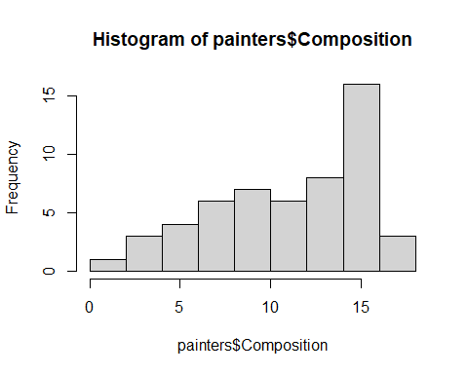

## Question 2:

*A bar chart of the Expression variable, using the barplot() function.*

- *Tip: use \`?barplot() to see which argument you need to change to get a horizontal bar plot* Also, wrap the painters$Expression with the table() function, then use the barplot() function

barplot(table(painters$Expression))

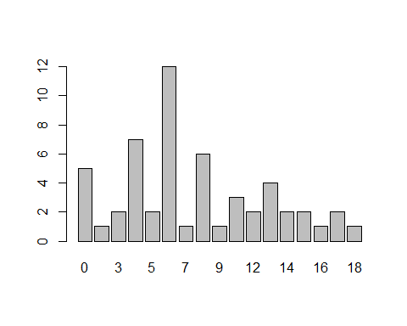

## Question 3:

*A pie chart of the Schools variable, using the pie() function.*

- *Hint: you need to wrap the `pie()` function around the `table()` function, because you need **counts** of each school, rather than just their label*

pie(table(painters$School))

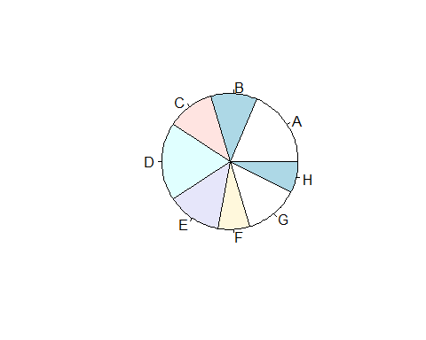

## Question 4:

*A histogram for the eruptions. R will automatically decide how to group your observations. Remember to plot* ***only*** *the eruptions variable.*

hist(faithful$eruptions)

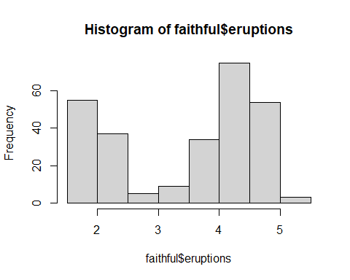

## Question 5:

*Another histogram of eruptions, but specify 2 data classes instead of the default values.*

hist(faithful$eruptions, nclass = 2)

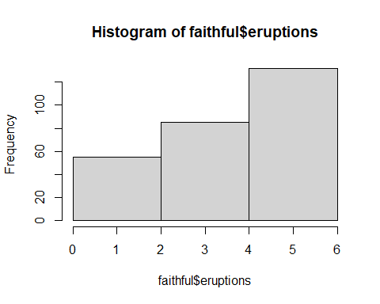

## Question 6:

*A boxplot of eruptions that is horizontal, rather than vertical.*

boxplot(faithful$eruptions,  
 horizontal = T)

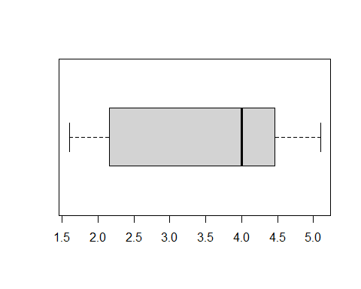

## Question 7:

*Repeat steps 4-6 (histogram, histogram with nbreaks = 2, and horizontal boxplot) on a dataset of your own choosing and interpret the data. You can also use functions such as mean, median, quantile, etc. to help interpret your data. Give each of your new plots x- and y-axis labels and a title*

mydata <- mtcars$mpg  
  
# Students don't have to use the par(mfrow); I've just used it to tidy the plots  
# a bit.  
  
par(mfrow = c(2, 2))  
  
hist(mydata,  
 xlab = "MPG",  
 ylab = "Frequency",  
 main = "Histogram of MPG")  
  
hist(  
 mydata,  
 nclass = 2,  
 xlab = "MPG",  
 ylab = "Frequency",  
 main = "Histogram of MPG"  
)  
  
boxplot(mydata,  
 horizontal = TRUE,  
 xlab = "MPG",  
 main = "Boxplot of MPG")  
  
par(mfrow = c(1, 1))

